CMPG 325 – COMPUTER NETWORKS
PHASE 2 – CLIENT IMPLEMENTATION REVIEW
Testing Documentation and Evidence

Project ID | CMPG325-2026-146
Client ID | CLI-146
Organisation | Pula Cloud Services (Kimberley)
Assigned Addressing Block | 172.30.96.0/23
Assigned Feature | Wireless Security – WPA2-PSK hardening
Change Request | CR3 – Guest Wi-Fi isolated from internal resources
Date | 1 October 2026

1. Test Scope
The Phase 2 implementation was tested to confirm VLAN operation, inter-VLAN routing, DHCP addressing, WPA2-PSK wireless security, wireless client connectivity, and enforcement of the Guest Wi-Fi isolation requirement. Packet Tracer captures show device identity, configuration context, and actual test output

1.1 Implemented Logical Networks
VLAN | Name | Network | Gateway
10 | STAFF | 172.30.96.0/26 | 172.30.96.1
20 | IT | 172.30.96.64/26 | 172.30.96.65
30 | SERVERS | 172.30.96.128/26 | 172.30.96.129
40 | GUEST_WIFI | 172.30.96.192/26 | 172.30.96.193
99 | MANAGEMENT | 172.30.97.0/28 | 172.30.97.1

1.2 Test Summary
ID | Test | Source / Area | Verified Result | Status | Evidence
T01 | Core trunk operation | SW1 | Required trunks and VLANs active/forwarding | PASS | Fig. 1
T02 | Router-on-a-stick gateways | R1 | All VLAN subinterfaces up/up | PASS | Fig. 2
T03 | DHCP allocation | R1 / PCs | Valid Staff and IT leases issued | PASS | Fig. 3
T04 | AP VLAN assignment | SW1 | AP1 in VLAN 10; AP2 in VLAN 40 | PASS | Fig. 4
T05 | Staff WPA2-PSK security | AP1 | PulaCloud-Staff uses WPA2-PSK with AES | PASS | Fig. 5
T06 | Guest WPA2-PSK security | AP2 | PulaCloud-Guest uses WPA2-PSK with AES | PASS | Fig. 6
T07 | Staff wireless connectivity | Laptop1 | Valid Staff address; gateway reachable | PASS | Fig. 7
T08 | Guest wireless connectivity | Laptop2 | Valid Guest address; gateway reachable | PASS | Fig. 8
T09 | Guest to Staff isolation | Laptop2 | Blocked | PASS | Fig. 9
T10 | Guest to IT isolation | Laptop2 | Blocked | PASS | Fig. 9
T11 | Guest to Server isolation | Laptop2 | Blocked | PASS | Fig. 9
T12 | Guest to Management isolation | Laptop2 | Blocked | PASS | Fig. 10
T13 | Staff to IT connectivity | Laptop1 | Reachable | PASS | Fig. 11
T14 | Staff to Server connectivity | Laptop1 | Reachable | PASS | Fig. 11
T15 | Guest ACL operation | R1 | ACL counters record matches | PASS | Fig. 12

2. Implementation and Test Evidence

2.1 Core VLAN Trunk Verification
SW1 carries the required VLANs toward R1, SW2, and SW3. The device title remains visible, confirming that the evidence comes from the Core Switch.
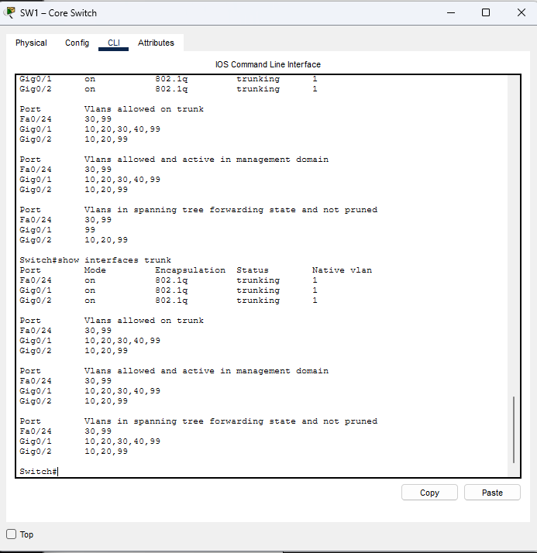
Figure 1: SW1 trunk interfaces, allowed VLANs, and forwarding VLANs.

2.2 Router-on-a-Stick Interface Verification
R1 provides the default gateways for VLANs 10, 20, 30, 40, and 99 through 802.1Q subinterfaces. All configured subinterfaces are shown in the up/up state.
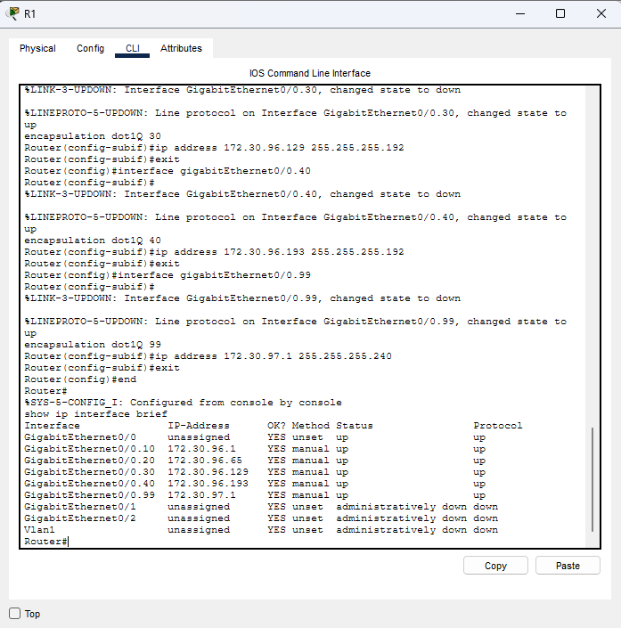
Figure 2: R1 subinterfaces and gateway IP addresses.

2.3 DHCP Address Allocation
The R1 DHCP binding table confirms that Staff and IT clients received valid dynamic addresses from the correct address pools.
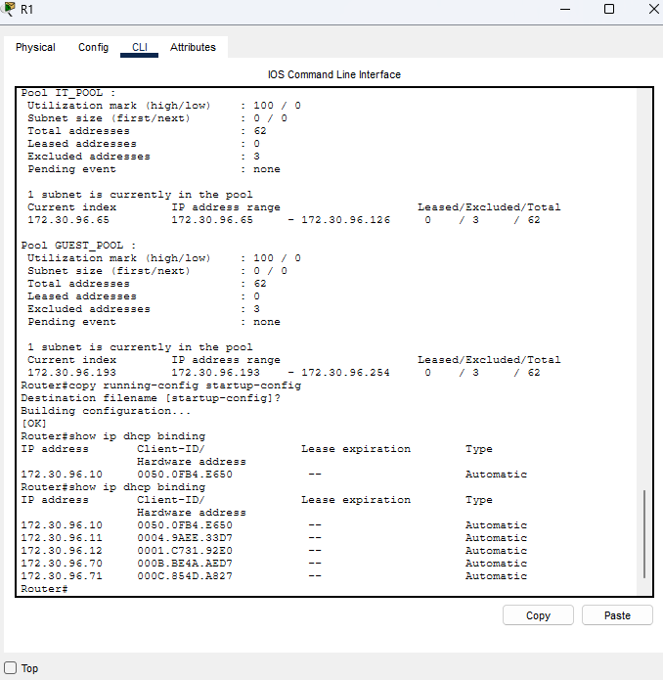
Figure 3: R1 DHCP bindings for PC1–PC5.

2.4 Wireless Access-Port VLAN Assignment
SW1 separates the wireless networks at the access-port level: Fa0/22 belongs to VLAN 10 (Staff) and Fa0/23 belongs to VLAN 40 (Guest Wi-Fi).
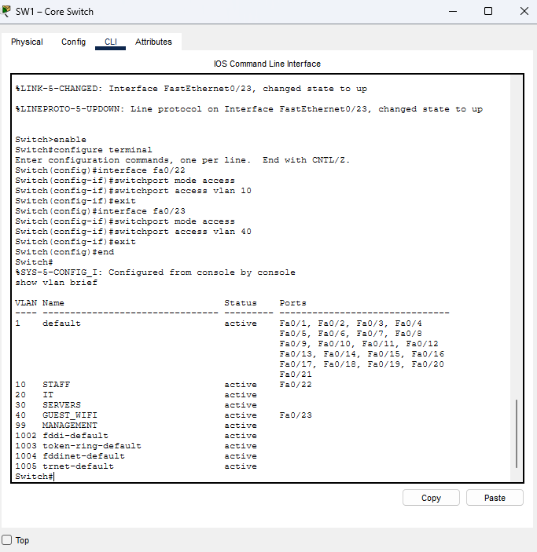
Figure 4: SW1 VLAN membership for the AP1 and AP2 access ports.

2.5 Staff WPA2-PSK Security
AP1 is configured with SSID PulaCloud-Staff, WPA2-PSK authentication, and AES encryption.
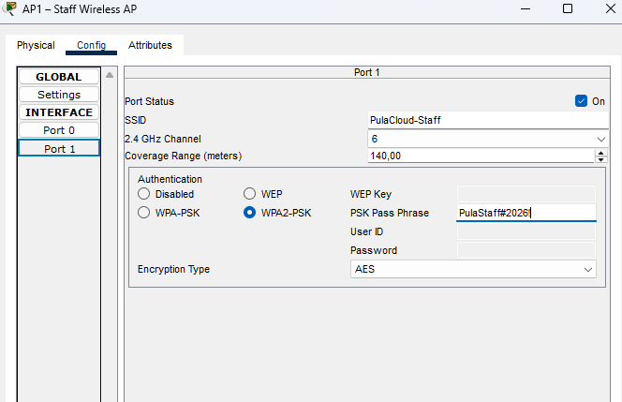
Figure 5: AP1 – Staff Wireless AP configured for WPA2-PSK with AES.

2.6 Guest WPA2-PSK Security
AP2 is configured with SSID PulaCloud-Guest, WPA2-PSK authentication, and AES encryption.
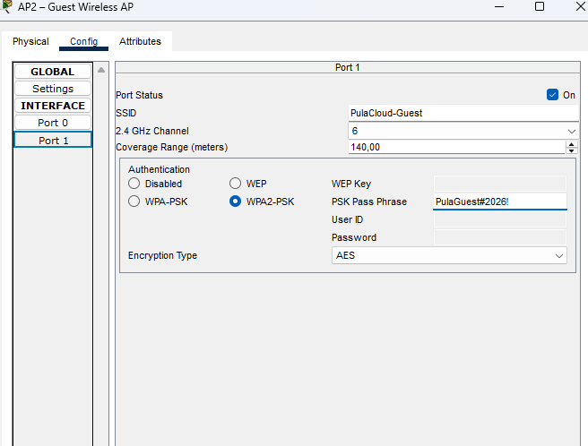
Figure 6: AP2 – Guest Wireless AP configured for WPA2-PSK with AES.

2.7 Staff Wireless Connectivity
Laptop1 received address 172.30.96.13/26 and successfully reached the Staff gateway 172.30.96.1 with 0% packet loss.
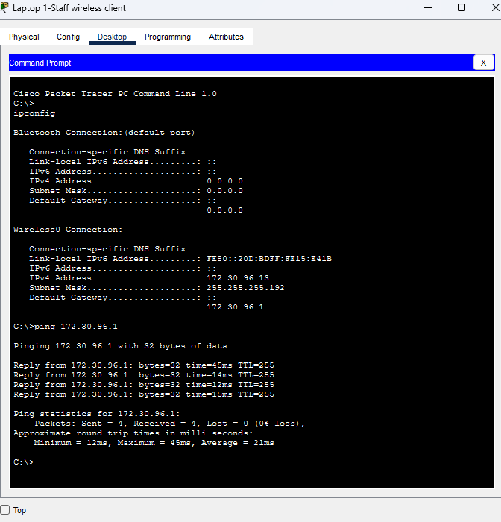
Figure 7: Laptop 1 – Staff wireless client addressing and successful gateway test.

2.8 Guest Wireless Connectivity
Laptop2 received address 172.30.96.201/26 and successfully reached the Guest gateway 172.30.96.193.
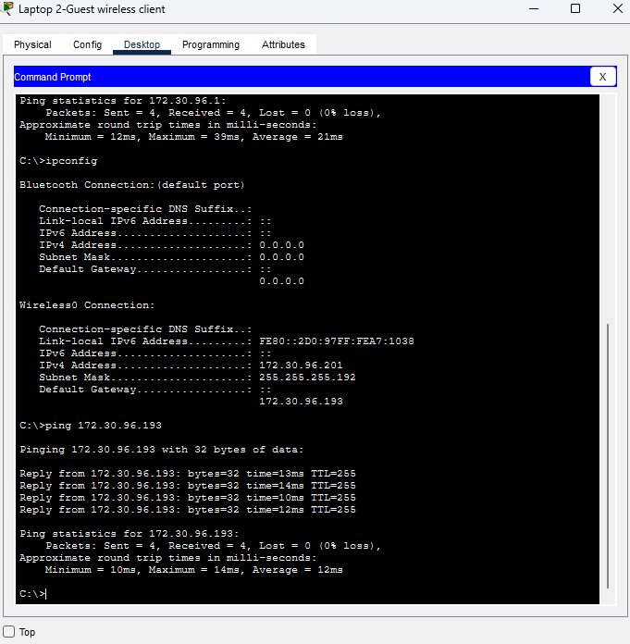
Figure 8: Laptop 2 – Guest wireless client addressing and successful Guest gateway test.

2.9 Guest Isolation from Staff, IT and Servers
After GUEST_ISOLATION was applied, the Guest client could not reach Staff, IT, or Server destinations.
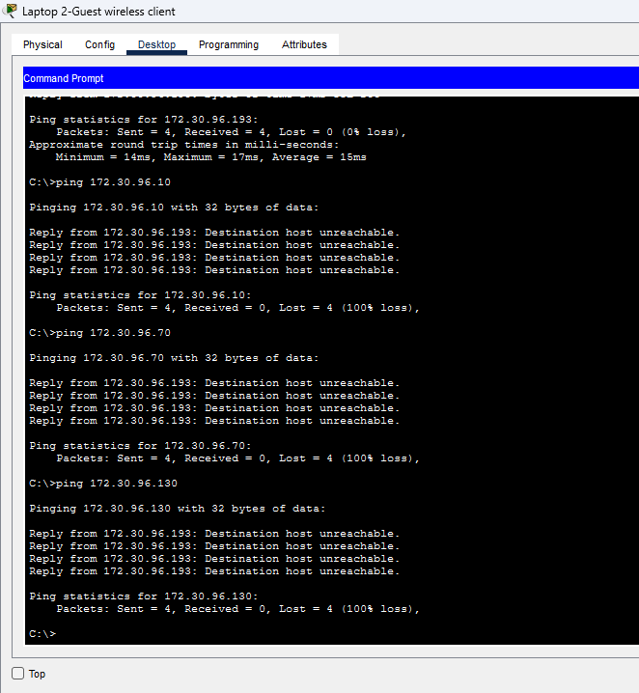
Figure 9: Guest client blocked from Staff, IT, and Server resources.

2.10 Guest Isolation from Management
The Guest client was also prevented from reaching the VLAN 99 management gateway 172.30.97.1.
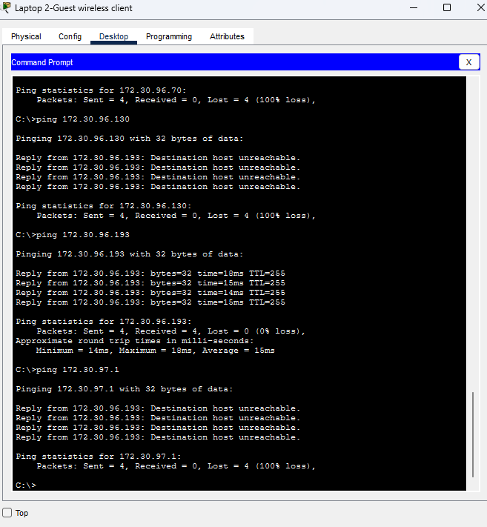
Figure 10: Guest client blocked from the Management network.

2.11 Internal Connectivity Preserved
The security policy applies to Guest traffic only. The Staff wireless client can still reach the IT network and Server1.
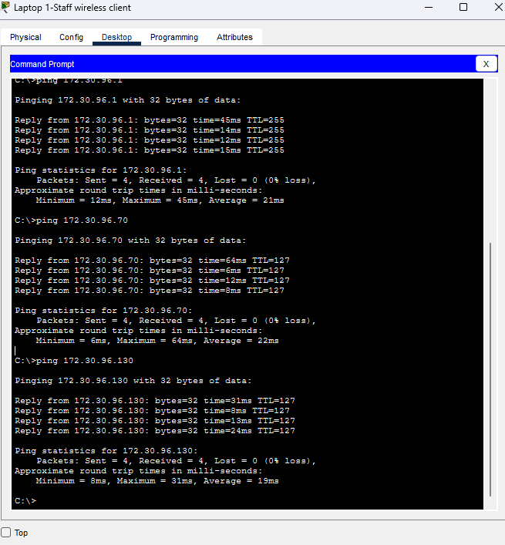
Figure 11: Staff wireless client successfully reaches IT and Server resources.

2.12 ACL Verification
The R1 GUEST_ISOLATION ACL contains explicit deny statements for Staff, IT, Server, and Management networks, followed by a permit-to-any rule. Match counters confirm that Guest test traffic was processed by the ACL.
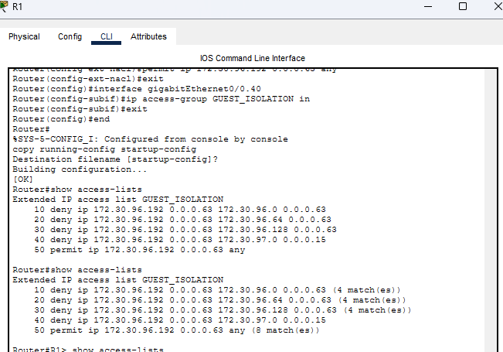
Figure 12: R1 GUEST_ISOLATION ACL configuration and packet match counters.

3. Test Outcome
The Phase 2 implementation passed all recorded tests. Staff and IT clients receive valid DHCP addressing; VLAN routing operates through R1; AP1 and AP2 use WPA2-PSK with AES; Staff and Guest wireless clients connect to their correct networks; and the Guest VLAN is isolated from Staff, IT, Server, and Management resources while legitimate internal connectivity remains available.

